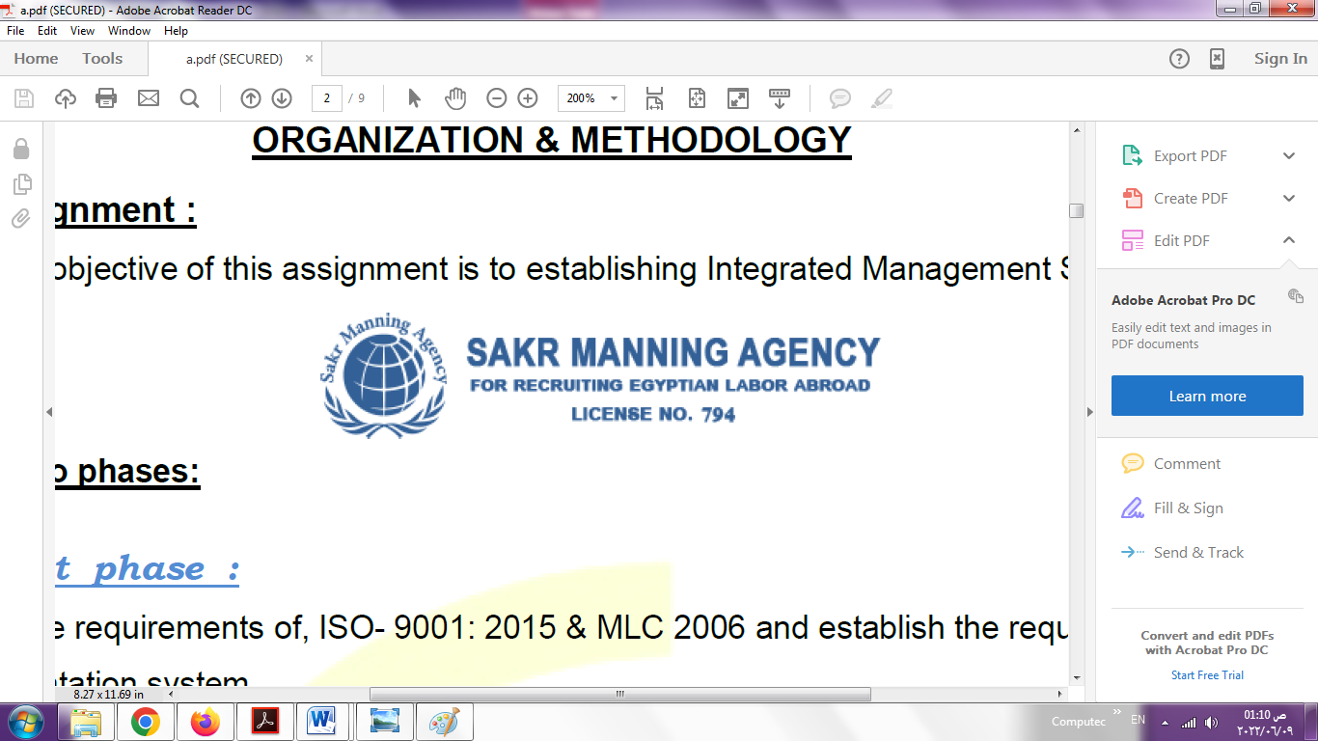 | SAKR MANNING AGENCY  FOR RECRUITING EGYPTIAN LABOR ABROAD | Issue Date | 15.05.2022
 |  | Revision Date | 01.02.2024
 | Crewing Management Manual  Seafarer Employment Application | Revision | 1.3
 |  | Page | 4

Application For Position as
Register Code. | ER-4.057
Other Position (If Any)
Register Date | 15.12.2024
Last up Date Data
Expected Salary / Available Date

1. PERSONAL DETAILS
Full Name | SALAH AHMED MOHAMED SHEHATA
Date Of Birth | 04/07/1977 |  |  |  |  |  | Marital Status |  |  |  |  | Single ☐ |  |  |  |  |  | Married ☐$√$
Nationality | EGYPT |  |  |  |  |  | Height (Cm) |  |  |  |  | 175 |  |  |  |  | Weight (Kg) |  |  |  |  | 80 KG
Place Of Birth | BEHERA |  |  |  |  |  | Overall Size |  |  |  |  | XL |  |  |  |  | Shirt Size |  |  |  |  | XL
Nearest Port | BOURG ELARAB |  |  |  |  |  | Trouser Size |  |  |  |  | 44 |  |  |  |  | Shoes Size |  |  |  |  | 45
2. EDUCATION
College / School | Diploma in Industry
Marline Test | Issued Date |  |  |  | Result % |  |  | Issued By (Authority) |  |  |  |  |  |  |  | Issued At
English Language | Fluent ☐ |  |  |  |  | Good ☐$√$ |  |  |  |  | Average ☐ |  |  |  |  | Poor ☐
……… Language  ( ARABIC ) | Fluent ☐$√$ |  |  |  |  | Good ☐ |  |  |  |  | Average ☐ |  |  |  |  | Poor ☐
3. CONTACT DETAILS
Home Address / City | RASHEED – ABDELSALAM AREF st
E-Mail | salah.shehata777@gmail.com |  |  |  |  |  | Mobile / Tel |  |  |  |  |  | +201094592552

4. TRAVEL DOCUMENTS
Type | Document No. |  |  | ISS. Date |  |  | Exp. Date |  |  | ISS. By (Authority) |  |  |  |  |  |  |  | Place of Issue
Passport | A29968385 |  |  | 08/03/2022 |  |  | 07/03/2029 |  |  | Egyptian Authority |  |  |  |  |  |  |  | BEHERA
Seaman Book | S00053805 |  |  | 20/05/2025 |  |  | 17/05/2030 |  |  | EAMS |  |  |  |  |  |  |  | Alex.
Other Seaman Book

5. PROFESSIONAL QUALIFICATION / CERTIFICATE OF COMPETENCY
Certificate Name |  |  | Number | Issue Date |  |  |  |  | Expiry Date |  |  |  |  | Issued By |  |  |  |  |  |  | Issued At
COC ( Rank) ………….. |  |  |  |  |  |  |  |  |  |  |  |  |  | EAMS |  |  |  |  |  |  | Alex.
GOC |  |  |  |  |  |  |  |  |  |  |  |  |  | NTRA |  |  |  |  |  |  | Cairo
6. NEXT OF KIN / EMERGENCY CONTACT
Full Name |  | MOHAMED AHMED SHEHATA |  |  |  |  | Relationship |  |  |  | BROTHER
Address / Country |  | RASHEED – ABDELSALAM AREF st
Tel. No./ Mobile |  | +201064462022 |  |  |  |  | Email |  |  |  | salah.shehata777@gmail.com
7. HEALTH CERTIFICATES & VACCINATIONS
Flag State |  | Number |  |  | Issue Date |  |  |  | Expiry Date |  |  |  |  |  | Issued By |  |  |  |  | Issued At
International Medical |  | 45372 |  |  | 02/06/2025 |  |  |  | 01/06/2027 |  |  |  |  |  | EAMS |  |  |  |  | Alex.
Yellow Fever |  | 5521 |  |  | 18/09/2016 |  |  |  | XXXX |  |  |  |  |  | Ministry of Health
Cholera |  |  |  |  |  |  |  |  |  |  |  |  |  |  | Ministry of Health
Covid-19 |  | Vaccination Name |  |  | First Dose |  |  |  | Second Dose |  |  |  |  |  | (Other Does or Remarks)

Proficiency In Personal Survival Techniques | NPST 1825 | 25/02/2020 | EGYPT | 20/02/2025
Fire Prevention and Fire Fighting | NFF 1647 | 25/02/2020 | EGYPT | 31/01/2025
Advanced Fire Prevention and Fire Fighting
Elementary First Aid | NFA 1885 | 25/02/2020 | EGYPT | 28/01/2025
Medical Care Studies
Personal Safety and Social Responsibilities | NPS 3949 | 17/03/2021 | EGYPT | 15/03/2026
Proficiency Of Security Awareness Training Seafarers | XNA 3149 | 03/06/2023 | EGYPT | 24/05/2028
Proficiency as a ship Security officer ( PSSO )
Proficiency In Survival Craft & Rescue Boats | NC 906 | 20/08/2019 | EGYPT | 07/08/2024
G.M.D.S.S
Communications
Advanced Communications
ECDIS Advanced Simulator (Management Level)
ECDIS Simulator (Operation Level)
Prevention and Combating of Marine Pollution
Radar & ARPA Simulator and Search &rescue
ARPA Simulator and Search
Marine Radar and automatic Radar Plotting
Bridge resource Management (B.R.M)
Engine resource Management (E.R.M)
Navigational Watch keeping
Proficiency for Rating forming part of Navigational watch (II/4) |  |  |  | EAMS / Alex.
High voltage training – operation of ship (1000 Volt and More)
Passenger Safety Cargo Safety and Hull integrity
Crowd Management Training
Crisis Management and Human Behavior Training
Safety training for Personal Prov. Direct Passengers
Practical Ability to Prepare Meals and (MLC 2006)
Personal Hygiene and Envir. Protection (MLC 2006)
Safety and Health in the Provision Meals (MLC 2006)
Food Storage and inventory Control (MLC 2006)
Ships Cook Certificate (MLC 2006) |  |  |  | EAMS / Alex.
Abel Seafarer Deck
Proficiency for Abel Seafarer Deck ( II/5 ) |  |  |  | EAMS / Alex.
Engineering Watch keeping |  |  |  | EAMS / Alex.
Proficiency for Rating forming part of a watch in engine room
Abel Seafarer Engine
Proficiency for Abel Seafarer Engine ( III/5 ) |  |  |  | EAMS / Alex.
Electro Technical Rating
Proficiency for Electro Technical rating ( III/7 ) |  |  |  | EAMS / Alex.
D.p. induction/ d.p. advanced
D.p. operator (unlimited)
Others

 | 9 - COMPLETE SEA – SERVICE DETAILS
Name: |  |  |  |  |  | Rank: |  | Register Code:
Company Name |  | Rank | Vessel Name/IMO Number | Flag | Signed On |  | Signed Off | Period | Vessel Type | D.W.T./ G.R.T | Engine Type | BH/ KW |  | Reason for Sign off
EGYPTION COMPANY |  | WELDER | NATIONAL STAR  7810961 | EGYPT | 28/08/2006 |  | 07/09/2006 | 2 M | GENERAL CARGO | 8230  5741 | MAN B&W | 3882 |  | COMPLATE
SEE SHORE |  | WELDER | LEOPARD  6037276 | PANAMA | 01/04/2007 |  | 12/02/2008 | 10 M | GENERAL CARGO | 9187  6167 | MAK 8M32 | 3840 |  | COMPLATE
SEE SHORE |  | WELDER | HUMMER  7942439 | ST.VINCENT | 01/04/2008 |  | 03/03/2009 | 13 M | GENERAL CARGO | 8750  6030 | SULZER/5RD68 | 4485 |  | COMPLATE
RED SHIPPING LINE |  | WELDER | PRINCESS DINA  8223854 | SIRRA | 15/11/2009 |  | 09/03/2010 | 4 M | GENERAL CARGO | 6470  3901 | HITACHI ZOSEN B&W | 3354 |  | COMPLATE
ENGE SHIPPING LINE |  | FITTER | MILAN STAR  7717200 | PANAMA | 29/03/2010 |  | 29/11/2010 | 8 M | GENERAL CARGO | 6474  4297 | MIRRLEES/KM8MAJOR | 3518 |  | COMPLATE
ENGE SHIPPING LINE |  | FITTER | MILAN STAR  7717200 | PANAMA | 27/08/2011 |  | 03/12/2012 | 16 M | GENERAL CARGO | 6474  4297 | MIRRLEES/KM8MAJOR | 3518 |  | COMPLATE
GOLF OF ADAN |  | FITTER | SILICA 2  8605208 | PANAMA | 20/07/2012 |  | 06/04/2013 | 9 M | BULK | 19075  12702 | SULZER 4RTA-58 | 122 |  | COMPLATE
GRIFFIN |  | FITTER | FREE GOODS  9107045 | LIBERIA | 12/06/2013 |  | 19/09/2013 | 3 M | GENERAL CARGO | 22051  13695 | AKASAKA 6UEC45LA | 7200 |  | COMPLATE
GRIFFIN |  | FITTER | MSTER NICOS  8610916 | BARBADOS | 03/09/2014 |  | 12/03/2015 | 6 M | BULK | 40908  26128 | MAN B&W | 9632 |  | COMPLATE
NAMA SHIPPING |  | FITTER | MAWADA |  | 15/06/2015 |  | 05/09/2015 | 3 M | PASSENGER
GOLF INTERNATIONAL .COM |  | WELDER | SALYM  9152844 | PANAMA | 16/12/2015 |  | 10/08/2016 | 8 M | BULK | 7435  4569 | HANSHIN 6CL LH41LA | PSX1 SET |  | COMPLATE
FINICIA |  | FITTER | AMAN  9159866 | PANAMA | 12/12/2016 |  | 21/04/2017 | 4 M | CONTAINER | 24341  1560 | MAN B&W | 12268 |  | COMPLATE
ALCO SHIPPING |  | FITTER | QAASWA  9438250 | EMIRATES | 18/08/2017 |  | 26/04/2018 | 8 M | CHIMICAL SERVICES | 9057  6190 | SKD-MAN 7L32/40 | 3310 |  | COMPLATE
EDT SHIP MANAGEMENT |  | FITTER | CREON | CYPRUS | 12/11/2018 |  | 07/01/2019 | 2 M | PETROLEUM SERVICES | 471  387 |  |  |  | COMPLATE
EDT SHIP MANAGEMENT |  | FITTER | EDT SERV | CYPRUS | 07/01/2019 |  | 01/06/2019 | 5 M | SUPAY | 1000  1374 |  |  |  | COMPLATE
LAMAR SHIPPING LINE |  | FITTER | GEORGE  917777 | PANAMA | 06/02/2019 |  | 31/08/2020 | 18 M | BULK CARRIER | 13347  7918 | MITSUI-MAN B&W | 4200 |  | COMPLATE
LEDY MAR |  | FITTER | LOUISA BOLTEN  9406049 | MARSHALL ISLAND | 25/04/2021 |  | 19/02/2022 | 10 M | BULK CARRIER | 30765  19972 | B&W | 6232 |  | COMPLATE
LEDY MAR |  | FITTER | SIDER JOY  9427586 | PORTUGAL | 02/07/2022 |  | 27/09/2022 | 3 M | BULK CARRIER | 26307  15861 | MAN B&W | 5850 |  | COMPLATE
LEDY MAR |  | FITTER | CARLOTA BOLTEN  9718442 | PORTUGAL | 17/11/2022 |  | 09/05/2023 | 6 M | BULK CARRIER | 37489  24198 | WARTSILA | 6350 |  | COMPLATE
LEDY MAR |  | FITTER | AMORGOS BOLTEN  9646716 | PORTUGAL | 02/09/2023 |  | 12/10/2023 | 1 M | BULK CARRIER | 36063  24247 | WARTSILA | 6350 |  | COMPLATE
ANGLO ESTERN |  | FITTER | MARGARITAVILLE  9187796 | BAHAMAS | 02/02/2024 |  | 03/05/2024 | 3 M | PASSENGER | 8600  53015 | WARTSILA 9L26 | 15200 |  | COMPLATE
DANAOUS SHIPPING |  | FITTER | EXPRESS BERLIN 9484924 | GREECE | 07/08/2024 |  | 17/10/2024 | 2 M | CONTAINER | 129760  113673 | SULZER | 68640 |  | COMPLATE
TARCO MARINE |  | FITTER | ALJABARA  7349039 | SAN MARINO | 27/12/2024 |  | 02/05/2025 | 5 M | RORO PASSENGER | 12035  3703 | MAN B&W | 10365

10. REFERENCES
No | Company / Management / Country | Position | Name | TEL | EMAIL
11. DECLARATION
Please answer the following questions:
- Did you suffer, or presently suffer from, any disease likely to render you unfit for services at sea or likely to endanger the health of other persons on board?  If yes, please provide details _______________________________________________  ______________________________________________________________________ | ☐YES ☒NO
- Did you suffer any accident, which rendered you temporary and/or partially disabled? | ☐YES ☒NO
- Did you ever undergo psychiatric treatment | ☐YES ☒NO
- Are you addicted to alcohol or drugs of any kind? | ☐YES ☒NO
I hereby declare that the above facts and information are true and accurate. I further consent to the holding and processing by (i) the owners of any vessel on which I may be assigned from time to time and (ii) the Managers and any direct or indirect parent or subsidiary or associated or affiliated company of the Managers (together referred to as "the Companies") for the purposes of my employment, of personal data about me contained herein, or provided to any of the Companies at a later date, including with respect to personal and pensions administration, employee management and as required to comply with any laws, regulations or contracts applicable to any of the Companies or their businesses. I understand that this data will be stored in the Managers’ database for the purposes of my current or future employment arranged by the Managers. Further, I confirm that the above may involve the transfer of my personal data within the Managers’ organization.
Place___________________________ Date ___________________________ Signature ______________________________
12.For Office Use Only
Initial assessment of applicant for further recruitment
Comments

Responsible person

Name / Signature _______________________________________________ Date ________________________________

